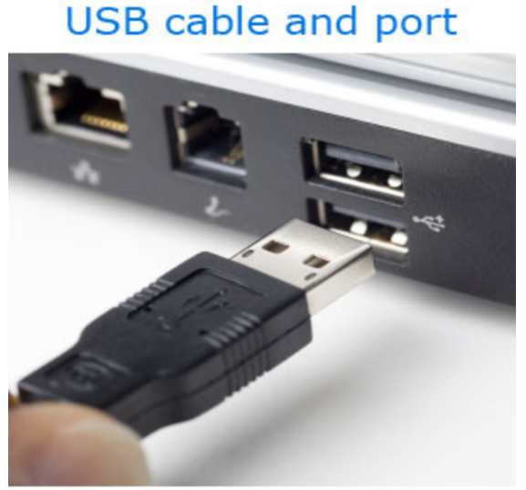

**STEP:-1 SELECT DEVICES AND PRINTERS**

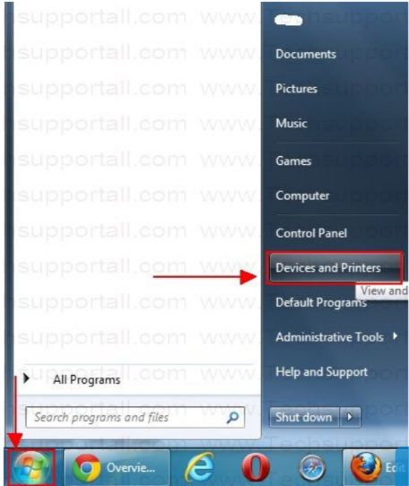

**STEP:-2 ADD PRINTE->WINDOWS UPDATE->SELECT PRINTER NAME->NEXT**

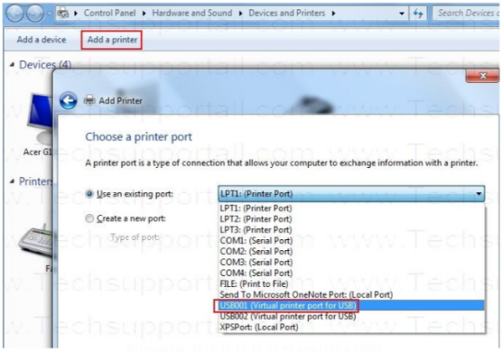

**STEP:-3 SELECT PRINTER NAME AND RELATED VERSION FOR DEVICE DRIVER**

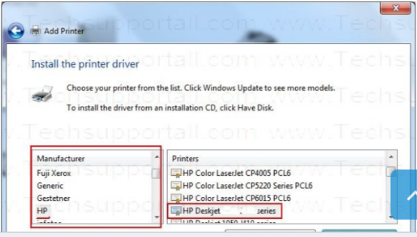

**STEP:-4 SELECT FOLLOWING CHOICE**

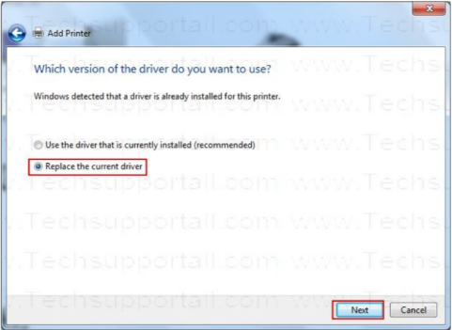

**STEP:- 5 TYPE YOUR PRINTRER NAME**

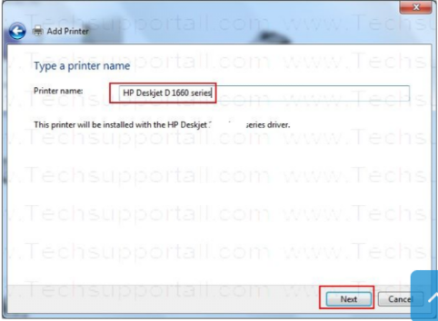

**STEP:-6 IF YOU WANT SHARING PRINTER TYPE NAME**

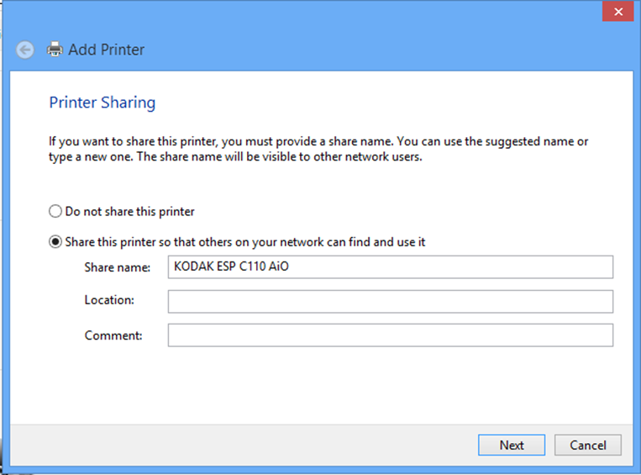

**STEP:- 7 SELECT TEXT PRINT A PAGE**  
